  SCHOOL OF COMPUTER SCIENCE | COMP-2120, Summer 2025  Object Oriented Programming  Using Java  LAB-1  TOTAL MARKS: 10

LAND ACKNOWLEDGEMENT
The School of Computer Science at the University of Windsor sits on the Traditional Territory of the Three Fires Confederacy of First Nations. We acknowledge that this is the beginning of our journey to understanding the Significance of the history of the Peoples of the Ojibway, the Odawa, and the Pottawatomie.

SUBMISSION DEADLINE: 10 AM, June-02, 2024

GENERAL INFORMATION
Welcome to the Lab Session of COMP-2120 where you will learn object-oriented programming
(OOP) using Java. Please, arrive early to the lab and get settled to start working on the lab. Arriving 20 minutes after the start of the lab will be considered late and can affect your lab participation point. There are eight lab exercises you need to complete throughout the course. Each week on Monday morning we will publish the lab exercise. You need to upload your code by Monday, 10 AM in the next week.

LAB GRADING AND ASSESSMENT
You need to explain your code to TAs in the lab to receive the marks. For example, consider a case where we publish a lab exercise on May 19. You need to upload the solution (i.e., your code) by 10 AM on May 26. YOU MUST demonstrate your results and explain code to the TAs to receive the marks. Thus, attending the lab sessions is mandatory (except this week as nothing is due). Note that your TAs are here in the Lab to help you learn. Feel free to ask questions and talk to them. Remember, the total Labs is worth 16% of your final grade.

Lab-1 Tasks

Task 1. Tools Installation and Setup (5 Marks)
In this task, you will install and setup all the tools that are necessary to write and execute java programs in your laptop.

- Install and Verify Java Version
  - Install Java Development Kit (JDK) in your machine. You can download JDK from this location: https://www.oracle.com/ca-en/java/technologies/downloads/. In this course, we are going to use JDK 8.

  - On macOS, click on Launchpad and search for “Terminal”. If you are using Windows OS, search for “cmd” and click on “Command Prompt” to open a Terminal window. To determine whether JDK is installed on the macOS system and what is the default version of the JDK, run the following command in a Terminal window as follows: java -version

  - You will get the following output if JDK is installed successfully.

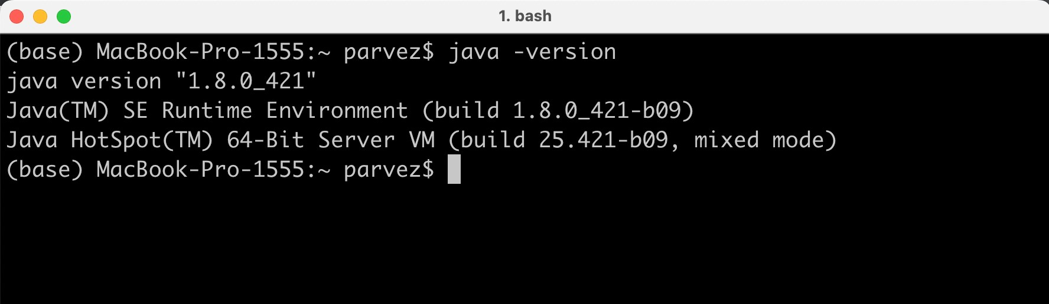

- Install Eclipse as the Java IDE
  - Create a new folder with the following name: comp_2120_workspace.
  - Download the latest Eclipse IDE. The complete instructions and the link is here:
https://www.eclipse.org/downloads/packages/installer
  - The Eclipse installer will show the list of packages available to Eclipse users. Select the following package: Eclipse IDE for Java Developers
  - Follow the instructions. When it prompts for workspace directory, choose the “comp_2120_workspace” folder you have created.
  - Run Eclipse, and create a project as described in step 3 to test the installation and get marks for Task 1.

- Use Eclipse to Write a Java Program:
  - Open Eclipse, go to File > New > Java Project, create a new project called: Lab1
  - When prompted, save the project to the workspace folder you created earlier.
  - While the project folder is opened in Eclipse, create a new Java class file named
“HelloWorld.java”: File > New > Class
  - Open the class file and type the following code snippet:

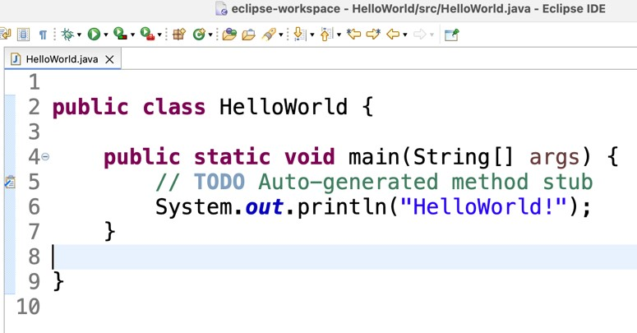
  - Build and run your project: Run > Run or Click on the button shown below:

Task-2: Solve a programming problem (5 Marks)
- You need to write your code inside the main method in a Java program. Create a new Java class file named: “Diamond.java”: File > New > Class
- Your program should read an odd number in the range 1 to 19 to specify the number of rows in the diamond. Your program should then display a diamond of the appropriate size. The following is an example where the number of rows in the diamond is 9. Your program should be able to handle incorrect input. For example, if the user enters an even number the program should ask to enter the number again.

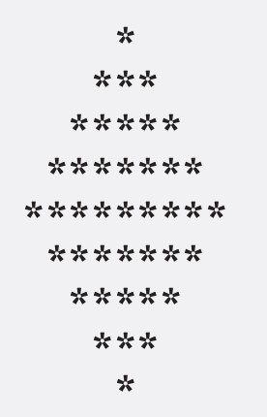

WHAT DO YOU NEED TO DO?
- Complete the program.
- Upload both files on the lab website. For each lab you will find a folder in the assignment section of the course website where you need to upload the files.
- Attend the lab. Show the TAs that you have installed, verified the Java version, and used Eclipse to create Java programs. Finally, explain your code to TAs.
- TAs can modify input to your program.

